PAIN ASSESSMENT
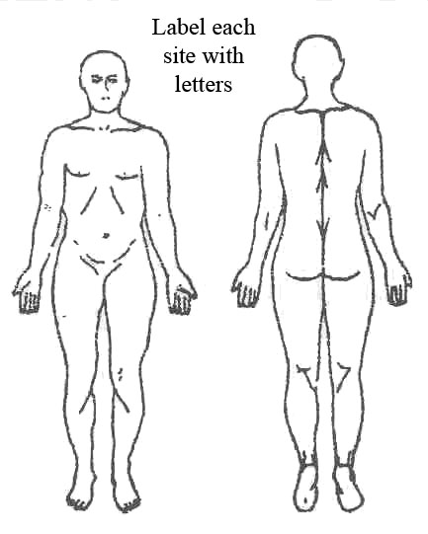

Cause of pain if known
Date | Resident’s own description of the pain and what makes it better or worst.  Examples: sharp pain, burning, aching, throbbing.
*For more information of analgesic (type, dose, strength, route) see Mar chart of the resident. Information about pain assessment and management see NGH Care Plan Guidelines.
Date | Time | Pain at sites |  |  |  | Pain scale | Analgesic given | Alternative methods of pain relief |  | Evaluation of  Pain Management/Pain scale |  | Name and signature
Date | Time | A | B | C | D |  | Name | Moving | Turning | Time |  | Name and signature
Pain Scale
0 1 2 3 4 5 6 7 8 9 10
No pain Mild pain Moderate pain Severe pain Very severe pain Worst pain possible

